Dylan Rondeau
Professor Butler
Data Science 140S
4/25/25
Final Project: Chess Data Analysis
Chess is one of, if not the most strategic game to this date. The game is played between 2 players against each other and the goal is to trap the opponents king and put them in checkmate. You are given 16 pieces to work with; 8 pawns, 2 knights, 2 bishops, 2 rooks and a king and a queen. Each piece has its own unique moves as well. To start the game one player will be assigned to the black pieces and the other to the white pieces and whoever is playing as white moves first. This makes me question if in such a strategic game, does going first make a big difference? Given the data received, there was so many variables that allowed me to think of more questions that intrigued me to find the answer of such as, does a players skill level impact the amount of moves they make and many more like. After analyzing this data set, it has enhanced my knowledge of the overall understanding of chess and also gave me some intel on what can give a player an advantage prior to starting the game.
The data set chose is filled with content and gave me the opportunity to go into so much detail and get a great understanding of the numbers behind the game. I was given 20 columns of data that each had 48,000 rows of data. The columns that I used in for my research was white Elo, black Elo, white clock, ECO, ply count, result, result-winner and commentaries. To give a little more background to what those variables are Elo for white and black is the rating system the chess community uses to determine how good a player is. The data ranges between 1900 to 3000+ in this data set. Chess games try their best to pair people of similar Elo to make the match fair. The next variable white clock and this is just how long the game was. ECO is an acronym for Encyclopedia of Chess Openings this is for when better players use well known openings. I picked this variable to use because I was also curious to see if a certain ECO opening had a higher win percentage. Ply count is the number of total moves that are made in a chess game. In this data set, the result is simply what color won or if the game was drawn by sating either 1-0 or 0-1 or even split. Result-Winner explains what color wins and commentaries tell you how the game was won. For example, white gets checkmates or black resigns. Here is a snapshot of what the data looks like.
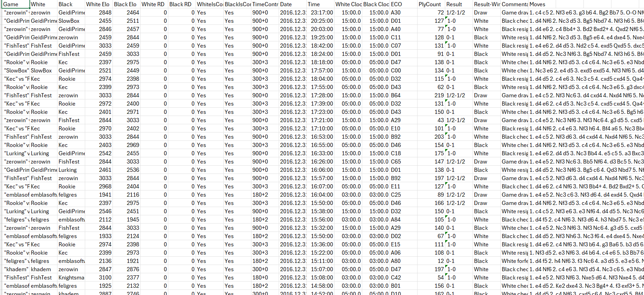
Figure 1.1 Dataset

My first question I wanted to get a better understanding of is whether playing white gives you an advantage by going first. To start the process, I had to view the data and make sure the data looked good and nothing unusual before I started. After that, I made a bar graph using excel simply just finding out the results using the result-winner column to see if anything jumped out at me and this is what I got.
Figure 2.1: Bar graph of Results of Games
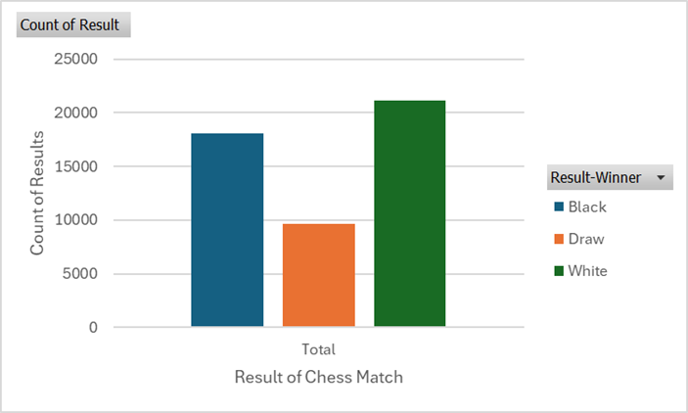
My first thoughts after seeing this chart were that it could definitely be a possibility that white wins a little more on average than black. I was reassured also by the large sample size as well. One thing I wanted to see before I confirmed this was if the players who were using white had a larger Elo than black. This would be a reasonable justification for white to have won so many more matches. To do this I went to Python and made 2 box plots of white Elo and black Elo and this is what really shocked me is they are perfectly the same.
Figure 2.2 and Figure 2.3: Box Plots of Elo

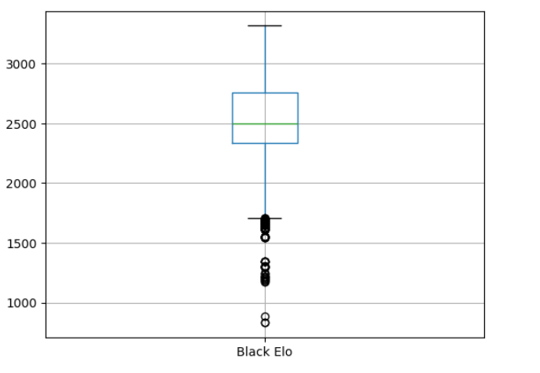
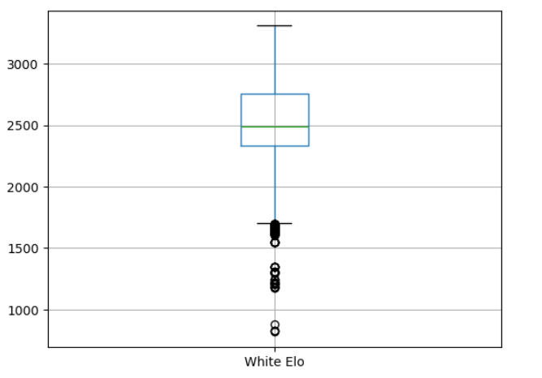
Confidently, it appears that there is no difference between the Elo between the white users and the black users, therefore it is easy to say that white does have an advantage by starting the match based on the fact that users of white have won significantly more times than players using black. My next question I was curious about after viewing the data was what the most common length of a chess match is. To find the results, Python was the best help. I made a bar graph using the column “White Clock” because the data was the same as black clock.

Figure 3.1: Histogram of all the games played length

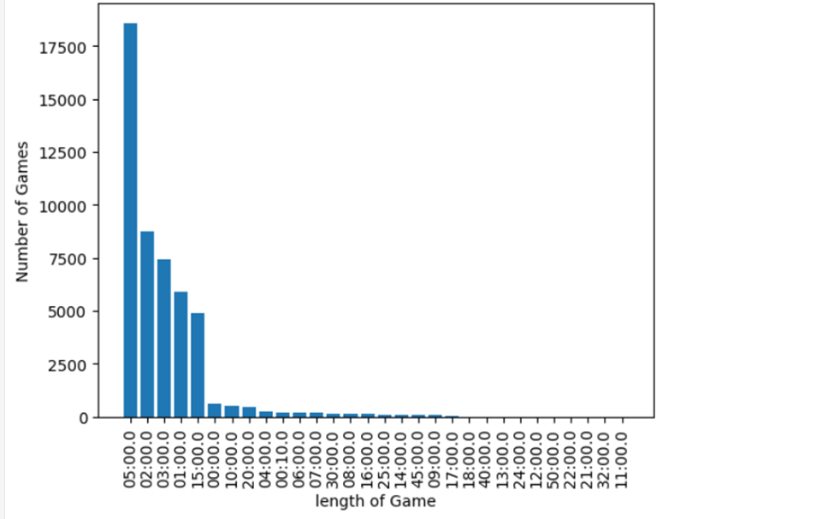
The results of this question were shocking. Chess is a very slow game that involves a high level of thinking and seeing that the most played length of game was 5 minuets by a large margin was very interesting. It goes to show that the chess professionals have such a quick-thinking brain and can anticipate future moves while making the correct ones in real time.
For the last question, does ply count have an impact on the result of a chess match and does having a higher ply count per match correlate to having higher Elo? The way this problem was approached was first creating a correlation matrix in attempts to solve the problem of a higher ply count correlating to having higher Elo. I used python for this question.
Figure 4.1: Correlation Matrix for Ply Count

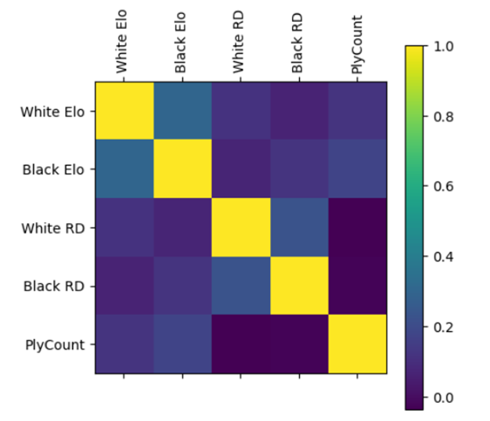

What this matrix can show us is that ply count does not correlate with Elo that much. The exact correlation score for white and black Elo was between 0.11 and 0.12 therefore we can conclude that there isn’t a strong enough correlation score to say that ply count correlates to having a higher rating.
After analyzing this data set, there are many takeaways that can truly impact the game of chess going forward. This data set can also give a better understanding of how the chess pros play their games and how smart you have to be to play those quick games. What stands out the most is the advantage that white has by going first. Going forward chess professionals should try to figure out some sort of scheme to beat white as black.

References
https://d2l.mountunion.edu/d2l/common/viewFile.d2lfile/Database/MzE1Njg2Nw/2016_CvC.csv?ou=62115 the data frame

